Application Development
- Individual Coursework Report –

SmartMed Pharmacy System


Course Submission Cover Sheet

Module: Application Development

Assignment no: 001

Weighting: 100% of the module mark

Deadline: 11.59 PM Tuesday the 30th June 2026
Module Leader: Ms.Shifani Mohideen Student ID: E301118 / 25045082
Please note that there are specific regulations concerning the use of AI and Academic Misconduct. Below are extracts from these regulations. By signing, you acknowledge that you have read and understood these extracts.
(signature:) M.N Sahla Baanu Date: 30/06/2026
This header sheet should be attached to the work you submit.
Academic Integrity means being honest in your academic work and your studies and making sure that you acknowledge the work of others and giving credit where you have used other people's ideas as part of presenting your arguments. Your assessment submissions must therefore always be entirely your own work, based on your own learning and appropriately referenced including how you have used Generative AI. The University regards the use of Generative AI applications by students to deceive to gain unfair advantage as academic misconduct. This usage includes:

- Plagiarism, where AI tools are used to generate output and ideas that are presented or submitted as if they were the student's own work, without proper citation or references.
- Where a complete assignment is created using Generative AI and represented as a student's own work, this will be regarded as contract cheating in the same way as commissioning an 'Essay Mill' or other third party to complete your work. Further information can be found on : Guidance on the use of Artificial Intelligence.

Academic misconduct: The University takes academic misconduct very seriously and seeks at all times to rigorously protect its academic standards. Plagiarism, collusion and other forms of cheating constitute academic misconduct, for which there is an explicit range of graduated penalties depending on the particular type of academic misconduct. The penalties that can be applied if academic misconduct is substantiated range from a reprimand to expulsion in very serious cases and for repeated instances of misconduct. You are also responsible for ensuring that all work submitted is your own and that it is appropriately referenced. The University does not tolerate cheating of any kind. You are strongly advised to familiarise yourself with the Academic Misconduct Policy and Procedure (Academic Misconduct), which list a range of categories of academic misconduct and associated penalties, covering instances of academic misconduct (plagiarism, collusion, exam cheating).

Introduction
SmartMed Pharmacy Management System is a desktop Windows Forms application developed in C# on .NET Framework 4.8. The system supports pharmacy operations for two roles: administrators who manage inventory, customers, and orders, and customers who register, log in, search medicines, and place orders.
The main objectives are to digitise medicine stock control, customer records, and order fulfilment; provide searchable medicine catalogues using linear search and filtering; and present sales and stock information through admin dashboards and reports. Data is stored in Microsoft SQL Server using a layered design: Forms (presentation), Services (business logic), Data (repositories), and Models (entity classes).

System Requirements

Functional Requirements
Admin Features
• Login – Secure login for admins.
• Manage Medicine Details – Add, update, delete medicine details (name, category, dosage, price, stock, supplier).
• Manage Customer Details – View and update customer information.
• Manage Orders – View all orders, update order status (Pending, Ready for Pickup, Delivered).
• Generate Reports – Sales reports, stock reports, and customer order history.
• Dashboard – Overview of total sales, medicines in stock, and active orders.
Customer Features
• Register/Login – New user registration and login.
• Search Medicines – Search by name, category, or price range.
• Place Orders – Add medicines to cart and place orders.
• Track Orders – View status of orders.
• Profile Management – Update personal details and contact information.
Additional Features
• Apply discounts or promotions on medicines.
• Include medicine expiry tracking notifications.
• Include prescription upload functionality for certain medicines.
• Export order history to PDF or Excel.

Non-Functional Requirements
• Usability - role-based navigation via AdminShellForm sidebar; standard WinForms controls for data entry and grids.
• Reliability - parameterized SQL queries prevent injection; validation runs before database access.
• Maintainability - separation of UI, services, and data access into distinct folders and namespaces.
• Performance - linear search is acceptable for typical pharmacy catalogue sizes.
• Security - passwords validated at login; session state held in Session service; admin and customer roles separated.

Hardware Requirements
• PC or laptop running Windows 10 or later.
• Minimum 8 GB RAM recommended for Visual Studio and SQL Server Express/LocalDB.
• Display resolution 1280×720 or higher for admin dashboard layout.

Software Requirements
• .NET Framework 4.8.
• Microsoft SQL Server
• Visual Studio 2019 or later with .NET desktop development workload

Development Tools and Technologies
• Language: C#
• UI: Windows Forms (System.Windows.Forms)
• Data access: ADO.NET (System.Data.SqlClient)
• Database: Microsoft SQL Server
• IDE: Visual Studio 2022
• Diagrams: draw.io

Design Diagrams

Architecture Diagram

Figure: Architecture Diagram

Use Case Diagram
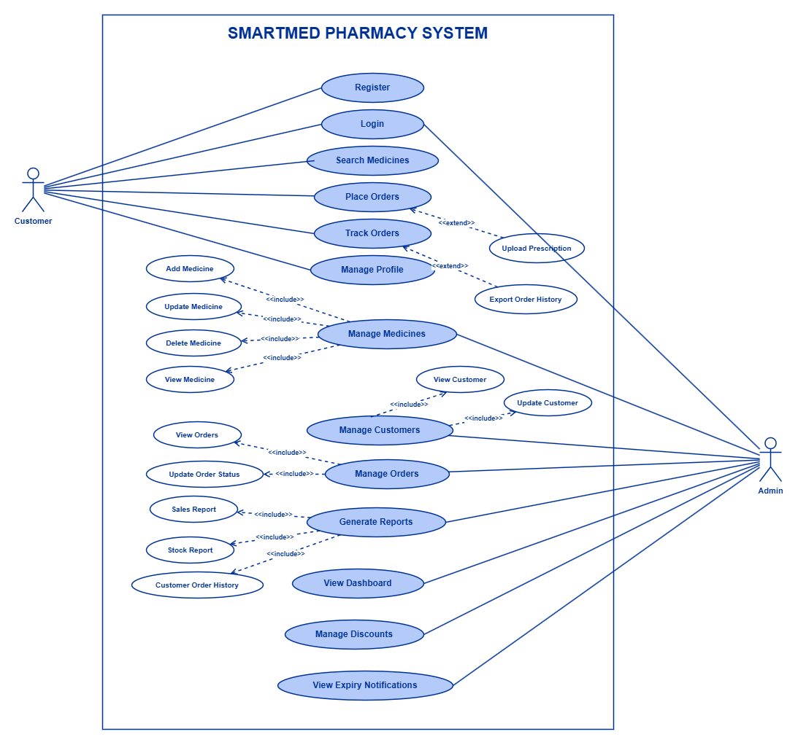
Figure: Use Case Diagram

ER Diagram
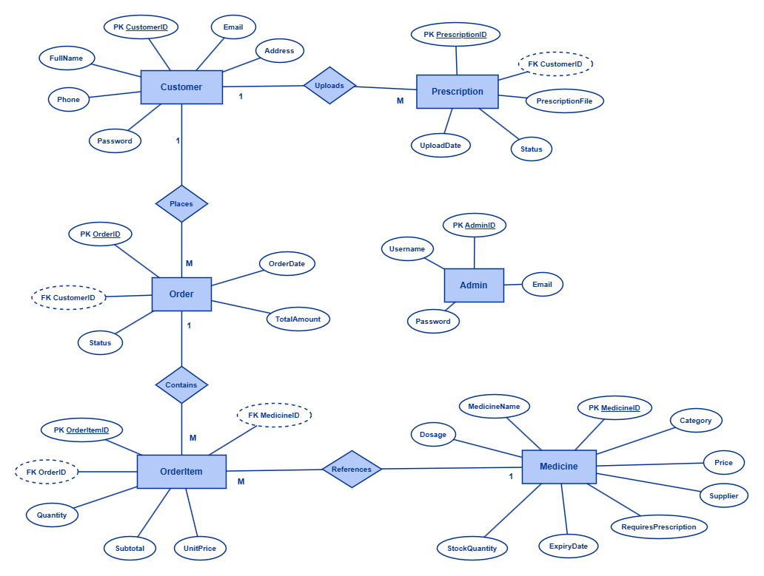
Figure: ER Diagram

Class Diagram
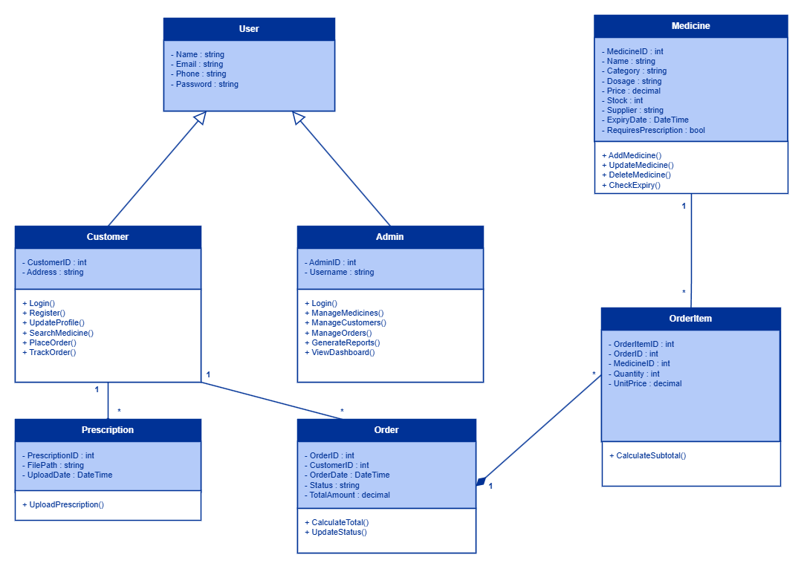
Figure: Class Diagram

Sequence Diagram
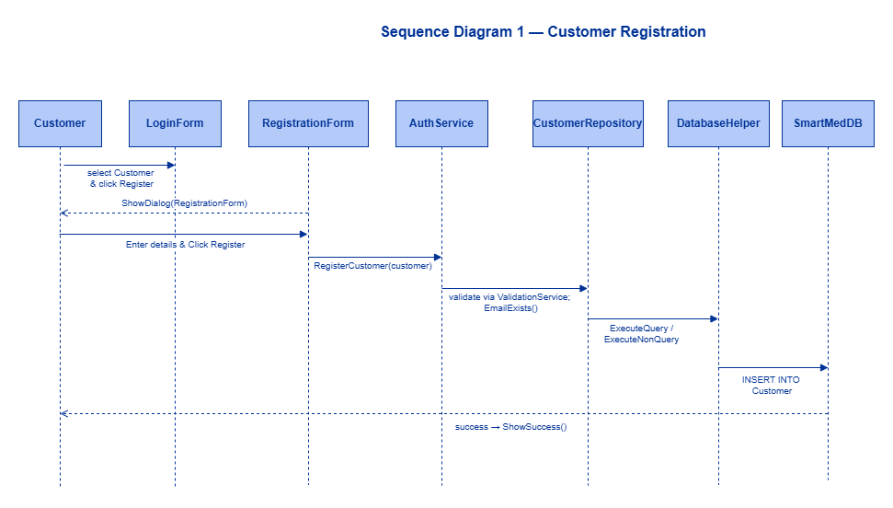
Figure: Sequence Diagram1
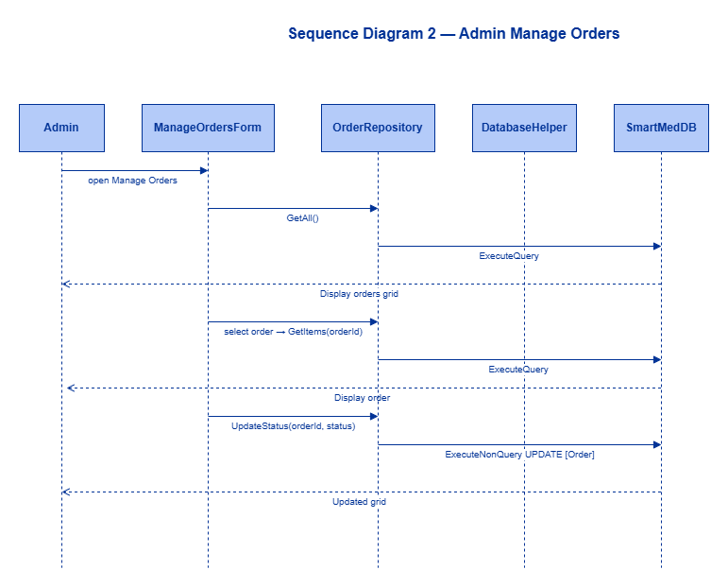
Figure: Sequence Diagram2

Database Design

Figure: Database Design

Description of Classes, Properties and Methods

Implementation

Brief Description of Functions

Code Snippets

Output Screens
Login screen
Admin dashboard

Manage medicines
Manage customers
Manage orders
Generate reports

User Manual

Installation Guide
Prerequisites: Windows 10+, .NET Framework 4.8, SQL Server, Visual Studio 2019+ (optional for running the built executable).
Database setup:
1. Open SQL Server Management Studio.
2. Execute Database/SmartMedDB.sql from the project folder.
3. Confirm database SmartMedDB is created with seed data.
Connection string:
1. Open SmartMed/App.config.
2. Set the SmartMedDB connection string to match your SQL Server instance (e.g. local instance or LocalDB).
Build and run:
1. Open SmartMed.sln in Visual Studio.
2. Set SmartMed as the startup project.
3. Build the solution (Ctrl+Shift+B) or run: dotnet build SmartMed.sln
4. Press F5. The Login form appears.
5. Admin login: username admin, password admin123.
6. Customer: register via Register button or use sample credentials from the SQL seed script.

Using the Application
Login - select Admin or Customer role, enter credentials, click Login.
Admin navigation - use the sidebar: Dashboard Overview, Manage Medicines, Manage Customers, Manage Orders, Generate Reports, Logout.
Manage Medicines - select a row in the grid to edit fields; use Add, Update, Delete buttons; view stock statistics at the top.
Manage Customers - select a customer to edit name, email, phone, address; save or delete as needed.
Manage Orders - select an order, choose a new status from the dropdown, click Update Status.
Reports - switch tabs for Sales, Stock, and Customer Order History; summary tiles show key figures.
Registration - customers complete the registration form with password confirmation; return to login after success.
Logout - use Logout in the sidebar or close (X) on the top bar to return to the login screen.

Reflection
Developing SmartMed improved my understanding of C# object-oriented programming and event-driven Windows Forms applications. Moving from console programs to a multi-form desktop app required thinking about navigation (AdminShellForm), session state (Session service), and keeping SQL out of the UI layer.
I valued the folder structure (Forms, Models, Data, Services) because changes to MedicineRepository automatically benefited every form that loads medicines. Debugging login across LoginForm, AuthService, and AdminRepository with breakpoints showed how requests flow through layers.
Challenges included configuring App.config so DatabaseHelper reads the connection string at runtime, and keeping WinForms layout manageable when building page content in code. Using DataGridView for CRUD screens and ValidationService for shared rules reduced duplication.
SearchService linear search was straightforward to implement and document, matching the coursework requirement. Future work includes completing the customer portal (cart, order tracking, profile), prescription upload, and PDF export for reports.
Working in Visual Studio 2022 and building with dotnet CLI gave flexibility. Overall the project strengthened skills in ADO.NET, layered design, and technical documentation aligned with UML diagrams in Docs/Diagrams/.

Conclusion
SmartMed Pharmacy Management System delivers a working admin desktop application for pharmacy inventory, customers, orders, dashboards, and reports. The implementation uses C# WinForms, SQL Server, and a clear layered architecture documented with architecture, use case, ER, class, and sequence diagrams.
Mandatory admin requirements are met: login, medicine CRUD, customer management, order status updates, reports, and dashboard metrics. Customer registration and login are implemented; extended customer features are planned. Linear search and filtering satisfy the search-algorithm requirement.
The report follows the coursework breakdown: requirements, design diagrams, class descriptions, implementation details, user manual, reflection, and conclusion. The solution is runnable against SmartMedDB seed data and suitable for demonstration and assessment.

